**A Job Application Website and WebApp**

1. **Website**

Domain: workabroadkenya.com

A website with the following pages

1. Home page
2. How it works
3. About Us
4. User pages
5. A backend for the admin to add job listings process application, check payments.
6. **Sketch**

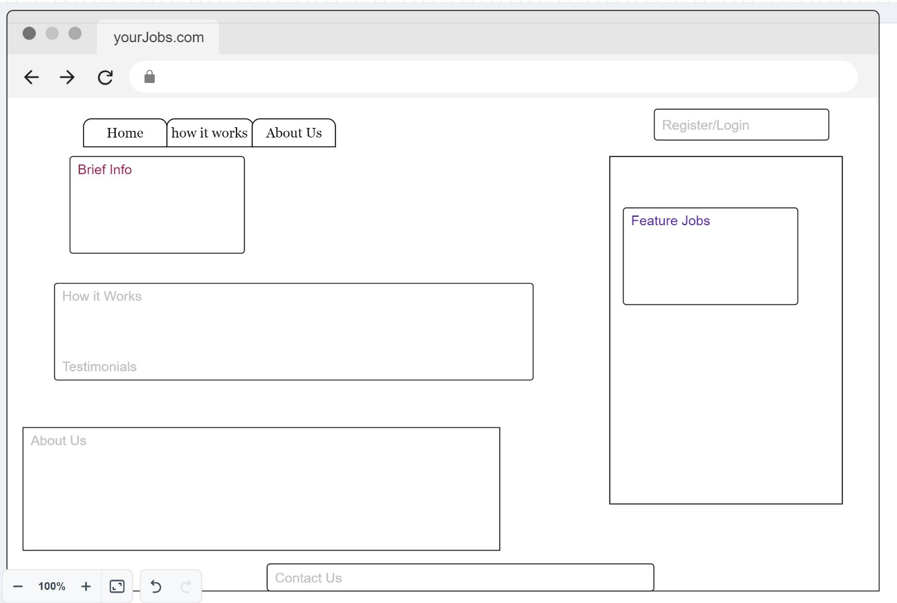

1. **Terms of Reference**

A professionally designed website with a web application that allows users to create profile and apply for listed jobs

The website will be responsive with a home page that has featured jobs with their expected salary and once a user clicks on any of the jobs they will be prompted to sign in or register.

How it works will explain the process and will have a testimonial page will have a slider with 20 testimonials, and about us page which will have key staff their designation and a contact area.

The jobs tabs will have all jobs listed but they can be filtered based on set criteria.

Jobs will have the city, country where they are based and expected salary.

A user has to register and create a profile then log in to apply for a job.

A user can click on any job (from the home page) view the description but when he chooses to apply, he needs to create a profile or log in.

* 1. **User Registration**

This entails capturing the username(email) and password,

After that successful registration and log in, the user can now create/update his profile.

* 1. **Profile Creation**

This information will be captured on profile creation, Mandatory except passport number.

1. Name (as it appears on the passport)
2. Mobile number
3. Date of Birth
4. Gender
5. Address
6. Country
7. City
8. Postal Code
9. Citizenship
10. Passport Number

The user will be assigned his profile ID (unique), A user can edit his profile on all the data captured. He can change his password as well.

* 1. **User Profile page**

Once the user create their profile and successfully log in, they will land to the listed jobs space,

All the jobs will be listed with have a unique job code, with appropriate filters (Country, Grade, and Pay).

Once a user selects his desired job, he will apply for it.

A user will be able to post messages from his profile to follow up on queries.

A user will be able to log out of his profile safely back to the home page of the website.

A user will be able to reset his password (via his email) once logged.

* 1. **Job Page**

Once the user clicks on the job,

He will the job title will be at the top of the page,

Job details as fed from the backend including the location of the job (country and city), Job Code, Salary range and the Job Description.

1. The user will apply for the job by filling in
2. Years of Experience
3. Education Level,
4. Skype ID if any,
5. If we can contact you for another role (yes/no).
6. Languages you can speak, multiple entries.
7. Upload a CV (3 pages max in word or pdf).

Add three buttons at the bottom:

* **Save** - enables a user to save keyed information and he can log out and complete the application later without losing the previous data.
* **Edit -** (once the application deadline lapses, user can’t edit)
* **Submit and Pay** - The fees will automatically be displayed based on the job grade. The payment gateway will be M-PESA to a till number that will be provided.

Once a user pays and his application is submitted, he will return to his profile (where there are other job listings) and receive a confirmation email for the job applied, application number and payment made.

All actively applied jobs with their codes will be listed in the user’s profile.

The whole process will take 3 to 5 months. As a notice. Once this time is expired and the user is unsuccessful, a user can apply for another job within the same category as the fees without paying any amount or request for a refund, refunds are made after 14 days. Processing fees are not refundable.

Once he has submitted, he can check the job status in phases,

* **Screening** - we are reviewing your application.
* **Interview/On Hold** - we are setting an appropriate interview with your employer; hold we are evaluating further.
* **Offer**/**Rejected** - you have a job offer; your application has been rejected.

All these stages will also have email notifications to the user once approved.

A user will be able to log out of his profile safely back to the home page of the website.

* 1. **Payment Set up**

After a user has completed their application and they are ready to pay, a fee based on the job grade will be displayed,

The payment will be the aggregation of the fees plus processing fees e.g. For job grade C, the fees will be $50 plus $5 = $5.

The user will automatically (Via STK Push) pay the fees, this will automatically prompt the user and they will complete payment or manually pay via their Safaricom M-Pesa then use the confirmation code received via SMS to verify payment by keying in their number and confirmation code to complete the payment.

A currency converter will be used to set the dollar to KES exchange. A user will see the current exchange rate displayed (e.g. 1 dollar = 135 KES). This currency exchange rate will be determined by the admin in the backend.

Once a user pays and confirmation is done, the job application will be submitted and the application will be listed in their profile (with an application number generated)

* 1. **Backend set up**

This the Admin/Superadmin profile.

This will enable the admin to post, edit, delete new or existing jobs.

Posted jobs will have a unique code and quantity (later displayed at the front end) defined while uploading, country and city (location), once the quantity is exhausted, the job can’t accept more applications.

The upload fields will include the

* Job Title
* Job Code
* Job Grading (for admin only)
* Salary scale in dollars
* Location (country and city)
* Date posted
* Deadline
* Job description
* Qualifications
* Local regulations

A user can apply for more than one jobs and pay as per the grade,

The grading is used to determine the amount a user will pay as agency fees on their profile.

The grading is as follows:

* Job class A will attract a fee of 100 dollars with a processing fee of 5 dollars.
* Job class B will attract a fee of 70 dollars with a processing fee of 5 dollars,
* Job class C will attract a fee of 50 dollars with a processing fee of 5 dollars
* Job class D will attract a fee of 30 dollars with a processing fee of 5 dollars
* Job class E will attract a fee of 20 dollars with a processing fee of 5 dollars.

The admin can view all users and check their payments and jobs applied,

He will also see the total amount collected in today and in total.

The Admin will also set the current exchange rate from the backend

He will have provisions to process their jobs. The admin will process the jobs in three stages,

* **Screening** – the agency goes through the applications
* **Interview/On Hold** – if the user is successful, he moves to interview phase or is put on waiting
* **Offer/Rejection** – Once the interview is through, he receives an offer or the application is rejected.

We don’t do passport processing, we will help whenever we are required with the visa process.